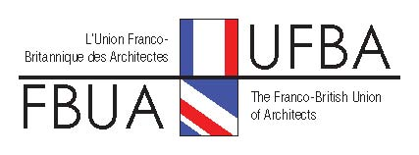

JOINT COMMITTEE – COMITE DE LIAISON London 14- 15 March 2014

PROGRAMME

Friday 14th March : RIBA Building Tour, Lecture & Dinner

5.30pm Guided tour of RIBA HQ. building
www.architecture.com

6pm Assemble in lobby adjacent Council Chamber and pre-lecture drinks.

6.30pm James Dunnett talk on 'Erno Goldfinger' in the Council Chamber.
Ernő Goldfinger (1902 - 1987) was a Hungarian-born architect and designer of furniture. He moved to the United Kingdom in the 1930s, and became a key member of the architectural Modern Movement. He is most prominently remembered for designing residential tower blocks, some of which are now listed buildings. He studied in Paris at the Beaux Art and having trained he became friendly with and was much influenced by Le Corbusier, Mies van der Rohe, Auguste Perret amongst others.
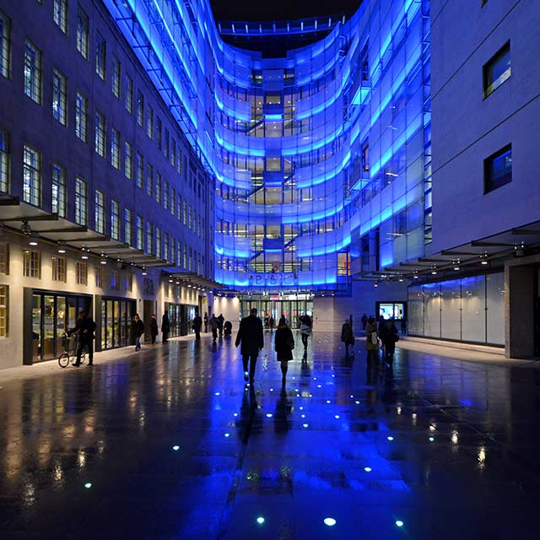
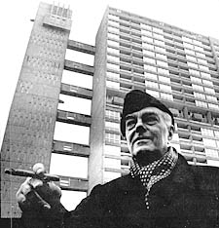
James Dunnett is a longstanding member of the FBUA and a Past Chairman of DOCOMOMO - UK. He has written and spoken extensively on architectural topics and specifically on Erno Goldfinger, in whose office he worked 1973-5. He put on the 1983 comprehensive Arts Council-funded exhibition of his work at the AA.

7.45pm Leave RIBA for nearby Restaurant passing through the new BBC Broadcasting House (MacCormac Jamieson etc).

8pm Meal in restaurant (Location to be confirmed).

Saturday 15th March : Canary Wharf

Introduction: See attached pdfs about Crossrail and Canary Wharf

Others links
www.crossrail.co.uk
http://www.canarywharf.com/visitus/
Google: Images for Canary Wharf

9.15am Meet beneath West India Quay DLR station (3 minutes walk from Canary Wharf Station - Jubilee Line)
Divide into 2 groups of up 20 in each group

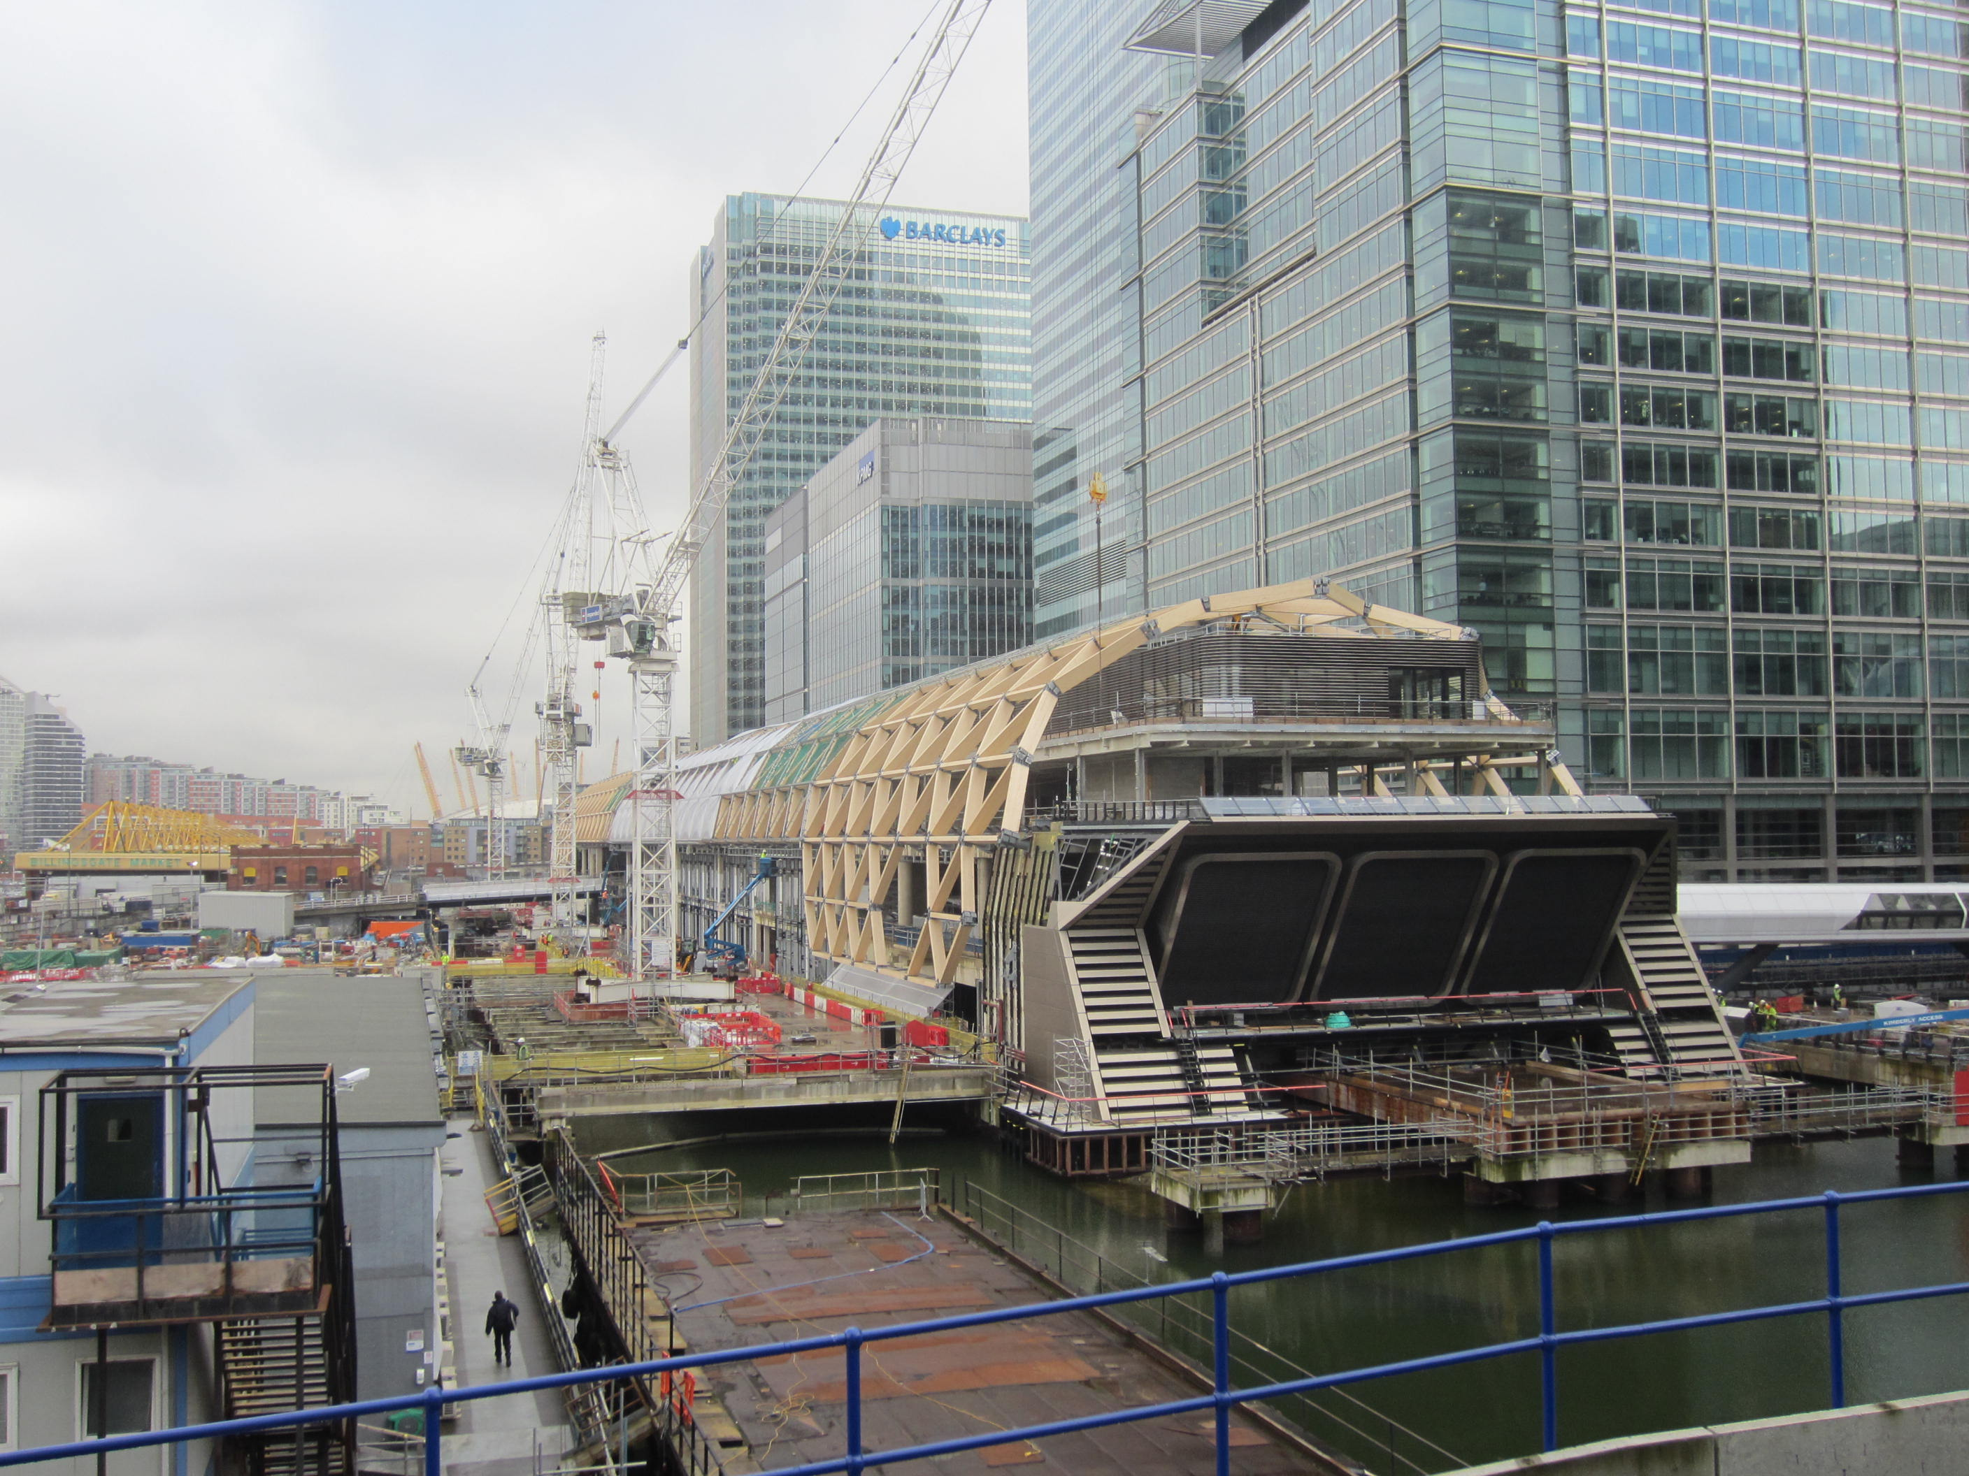
9.30am Group A – Report to Crossrail site office immediately next to West India Quay station (Canary Wharf Contractors – See Map)

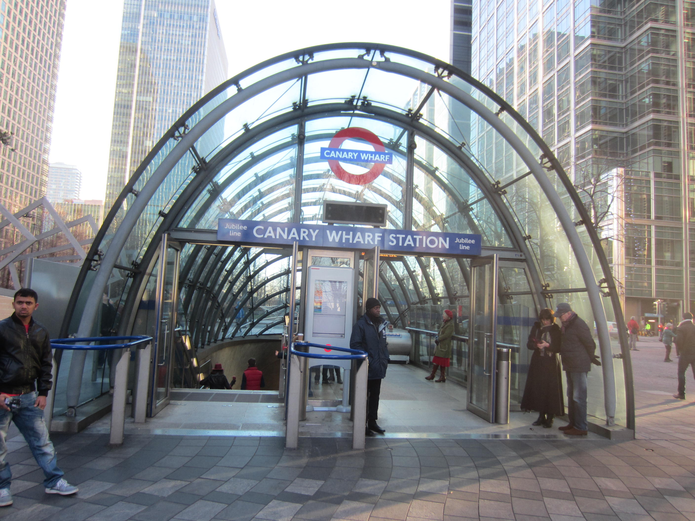
The tour will include : Foster designed roof under construction, some of the pavilion structures at park level, the retail zones, the ticket hall and the platforms 28m below the dock : It is all a construction site and PPE will have to be worn : Everyone will have to provide their shoe sizes! : The visit will take about an hour and a quarter.

9.30am Group B : General walk round Canary Wharf site

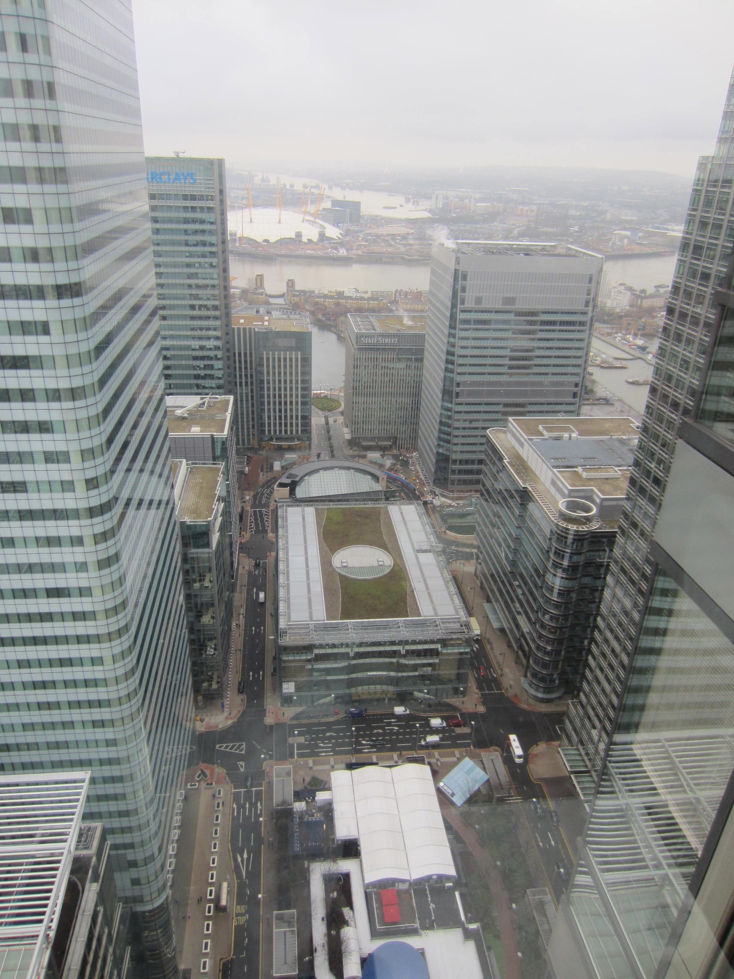
10am Group B : Check in at ‘One Canada Square’ the original Canary Wharf Tower : Check at Reception and pass for ‘Level 39’

Level 39, One Canada Square, Canary Wharf, London E14 5AB Telephone (0044) 3668 3600

Level 39 has been set up by the Canary Wharf/Mayor of London using the whole of the 39th Floor of the tower : It is to promote new businesses and thinking about the development of the city. There will be a conducted tour and an opportunity for a cup of coffee etc. Also amazing views.

Web link : ‘level39.co/level39/introduction’
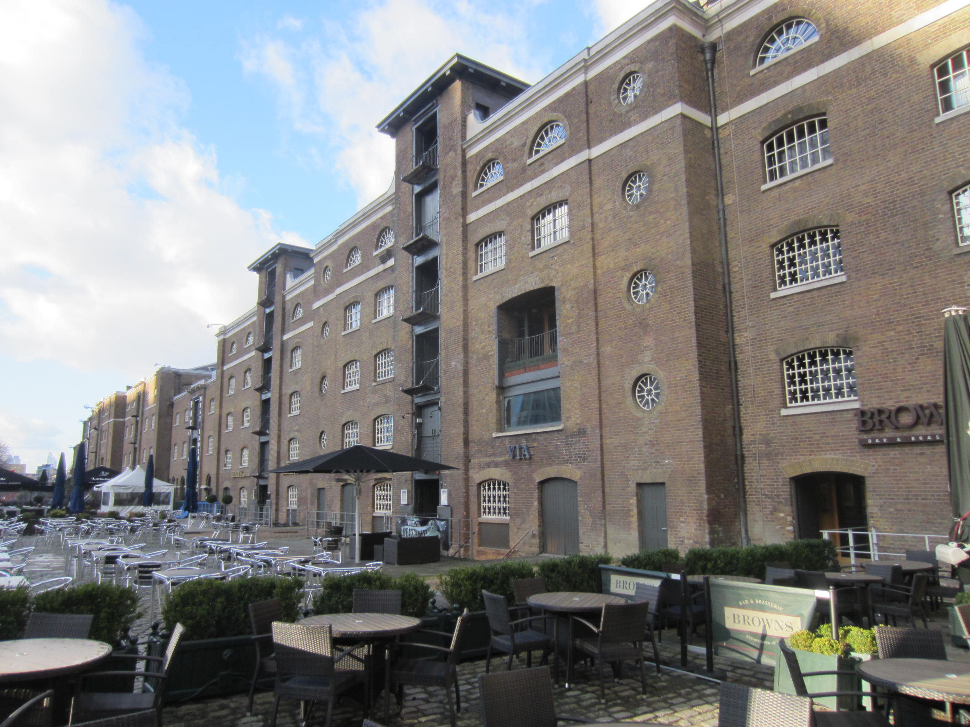
11am Groups swap over : Group A reports to Level 39 first then general walk around Canary Wharf : Group B to Crossrail.

12.30pm Lunch at Brown's Restaurant in converted wharf building adjacent West India Quay. (Telephone (0044) 207987 9777)

See attached reply form

We need confirmation by no later than Monday 24 February 2014.

