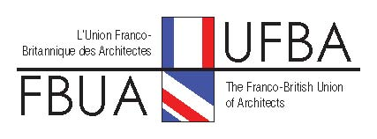

JOINT COMMITTEE – COMITE DE LIAISON London 14 - 15 March 2014

Application Form

Your Name(s): . . . . . . . . . . . . . . . . . . . . . . . . . . . .

Friday Lunch – No. Attending . . . . . at £30.00 each* £. . . . .

Friday Drinks & Lecture – No. Attending . . . . at £10.00 each £. . . . .

Friday Dinner – No. Attending . . . . . at £35.00 each* £. . . . .

Saturday Crossrail Visit – No. Attending . . . . .at £5.00 each £. . . . .

Saturday Level 39 – No. Attending . . . . . at £5.00 each £. . . . .

Saturday Lunch – No. Attending . . . . . . at £27.50 each* £. . . . .

TOTAL £. . . . .

* Restaurant costs include 2 or 3 courses plus beverages, service etc.

Please make cheques payable to the ‘Franco British Union of Architects’ and send them with your completed application form to:

Ralph Carpenter
Secretary to British Section FBUA
Top of the Hill, Hartest, Suffolk IP29 4ET
ralph@modece.com

Alternatively you may like to submit this form by email and make a direct transfer to FBUA Bank Account (Sort Code: 56-00-34/ Account No:52460541). If you transfer money into the account, please send an email to Cedric Mitchell cedricm8@gmail.com Copied to Ralph Carpenter (see above for email address).

If you are signing up for the Crossrail visit, please provide your shoe size(s) :

Name: Shoe size :

Name: Shoe size :

We need payment and confirmation by no later than Monday 24 February 2014.

